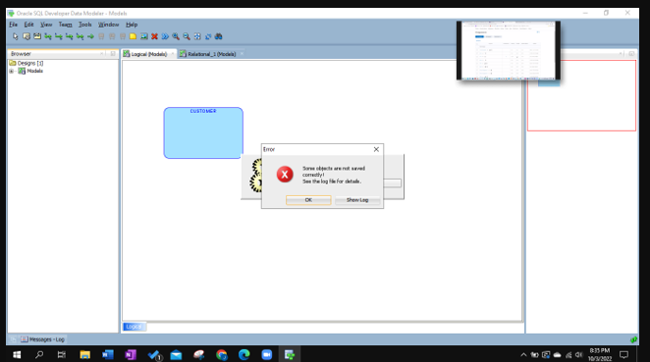

If you get following error while saving the design, “Some objects are not saved correctly”, click on OK. Your design will be saved without issues. You can open the design and verify it.